**SHRIMP AND GRITS WITH TASSO GRAVY**

Vegetarian and other protein versions available.

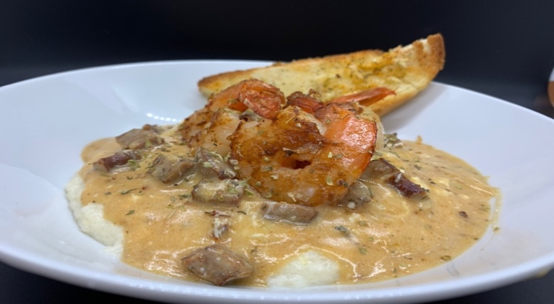

Creamy Low Country Style Grits in a Delectable Gravy!

***Grits: Betcha Can’t Eat Just One!***

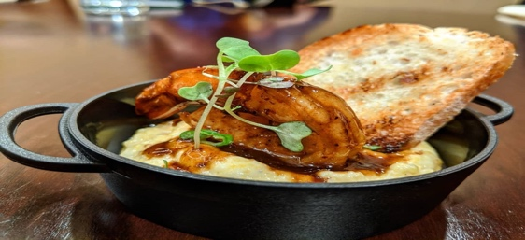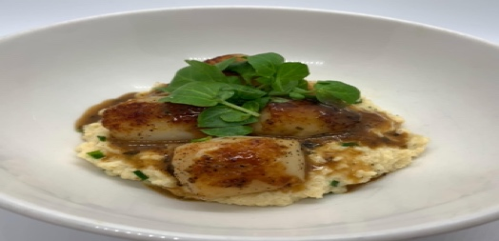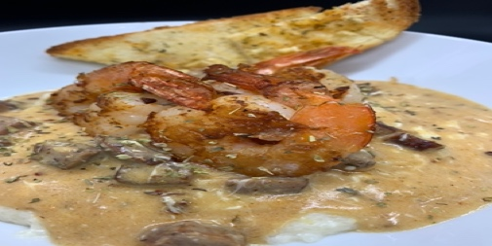

Join us at the next COMFORT N SPICE

**COOK ALONG**

We Cook… We Laugh… We Eat… We Wine Down... TOGETHER!



Friday, June 23, 2023 6:30pm CST

$25 / person $35 / group of 4 or less*

Register at [comfortnspice.com](http://comfortnspice.com)