

Sinfully DelIcicious Chicken

and Cauliflower Wings

Friday, July 29, 2022

6:30pm CST

Ω

*All reservations must include payment in full. Recipes and handouts will be provided via email approximately 5-7 days before class time. Please register at least 2 days before to ensure timely delivery of materials and a non-rushed shopping experience. Please reference the waiver form on the website for additional information.*

*Group rates may be available.*

**A Little sweet, a little spicy, a Little wicked, a LITTLE *Healthier!***

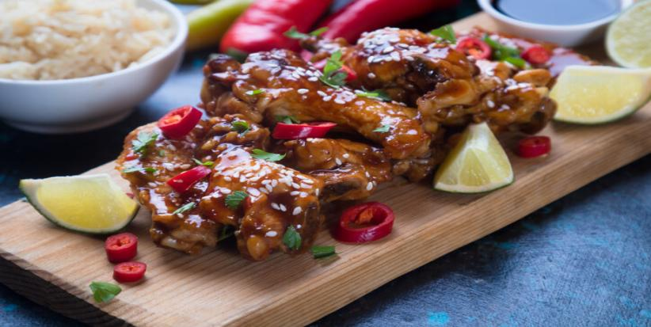

Cost: $25/person; $35 per household of 4 or less.

**Register at: COMFORTNSPICE.COM**

## Oh my! These are so delicious! A little Sweet, A little Spicy, Perfect texture!

G

Should I tell him?