SHRIMP AND GRITS WITH TASSO GRAVY
Vegetarian and other protein versions available.

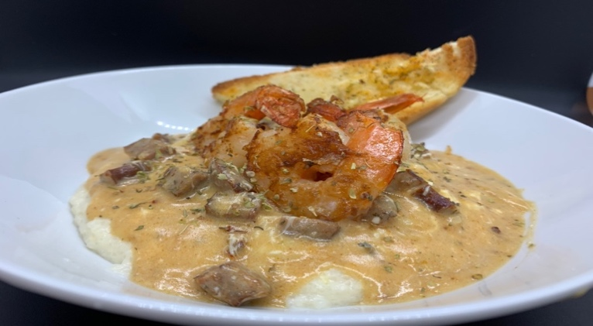

Creamy Low Country Style Grits in a Delectable Gravy!
Grits: Betcha Can’t Eat Just One!

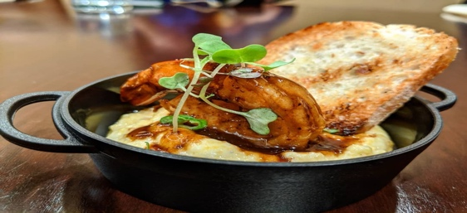
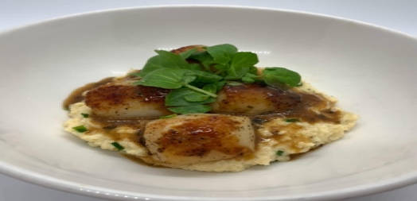
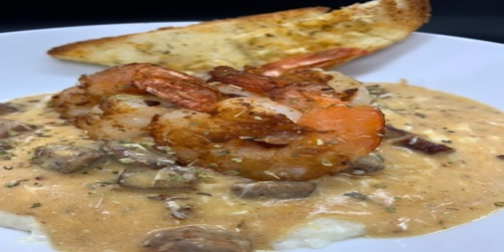

Join us at the next COMFORT N SPICE
COOK ALONG
We Cook… We Laugh… We Eat… We Wine Down... TOGETHER!


Friday, June 23, 2023 6:30pm CST
$25 / person $35 / group of 4 or less*
Register at comfortnspice.com

