



Sinfully DelIcicious Chicken

and Cauliflower Wings

Friday, July 29, 2022
6:30pm CST
Ω

All reservations must include payment in full. Recipes and handouts will be provided via email approximately 5-7 days before class time. Please register at least 2 days before to ensure timely delivery of materials and a non-rushed shopping experience. Please reference the waiver form on the website for additional information.
Group rates may be available.

A Little sweet, a little spicy, a Little wicked, a LITTLE Healthier!
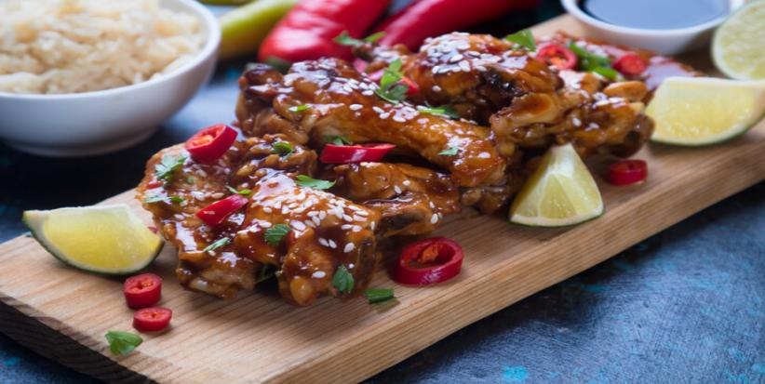
Cost: $25/person; $35 per household of 4 or less.
Register at: COMFORTNSPICE.COM

Oh my! These are so delicious! A little Sweet, A little Spicy, Perfect texture!

G
Should I tell him?

